**Why Can't I Go   
to School?**

Merton Primary school will let my parents/carers know when it is safe for me to come back to school. Until then, I will stay at home and be safe.

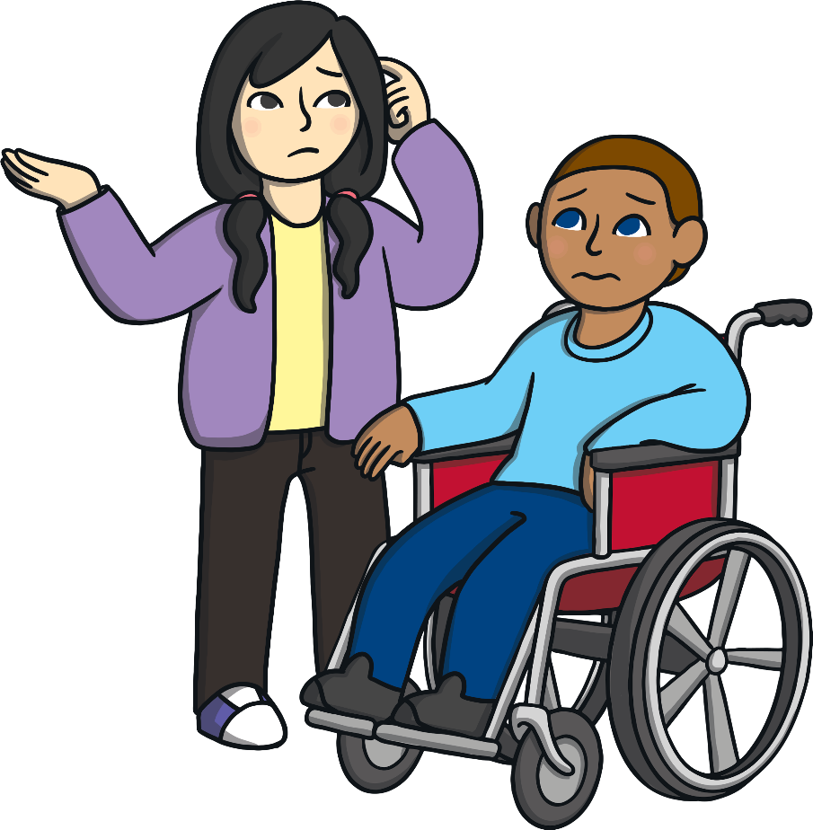

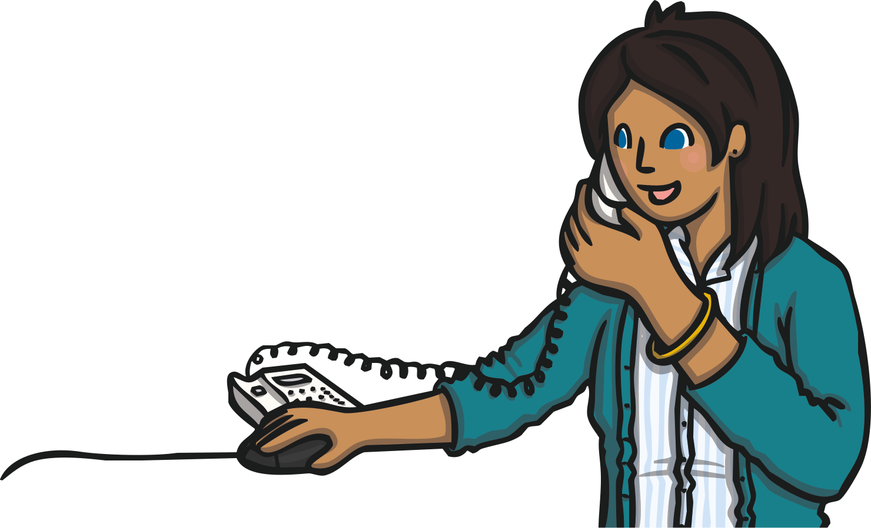

My school, Merton Primary School, is closed. The school is closed to keep me safe.

My name is .

My teacher is .

I am years old.

I go to school.

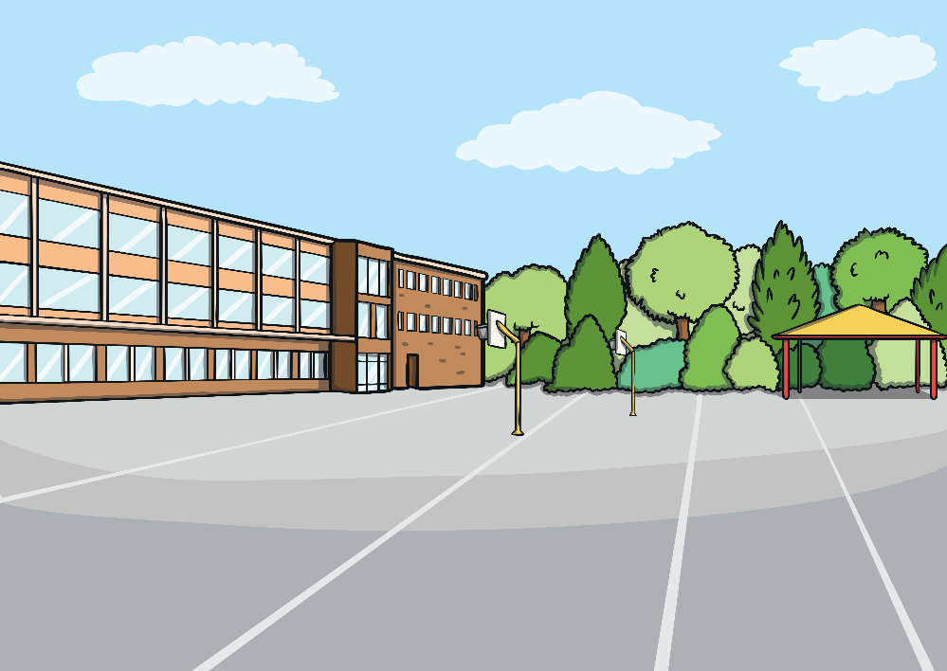



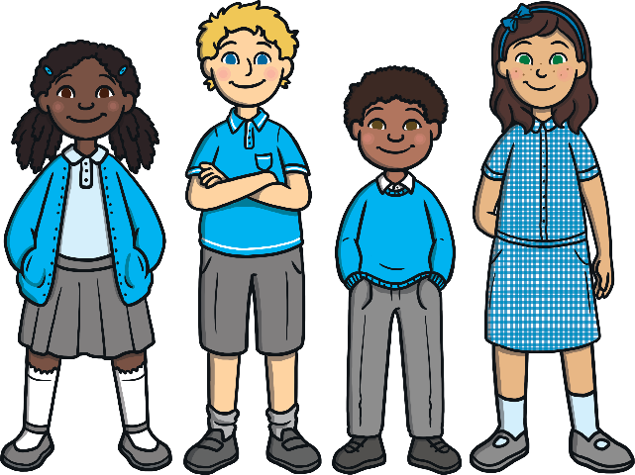

Being at home is best for me. At home, I have less contact with other people - just my family. This will keep me safe.

At the moment, there is a virus called the Coronavirus which is spreading across the country. Coronavirus spreads quickly and makes people sick and this is why Merton Primary School is shut as the teachers want the children to stay at home and be safe.

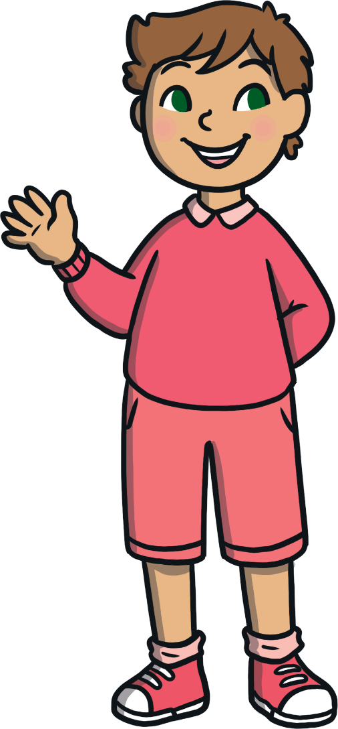

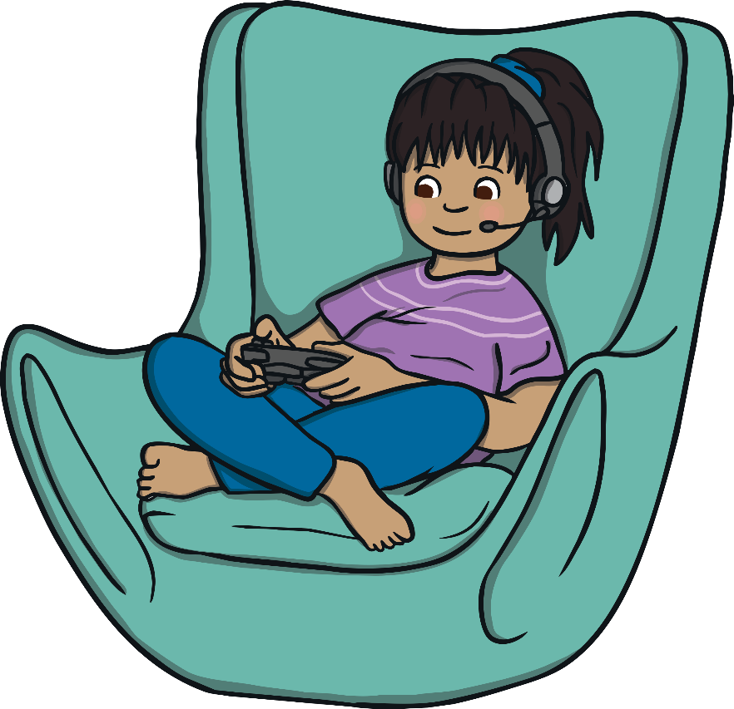

I might feel sad because I am not able to go to school. This is OK. Most children will feel sad as they will miss their teacher and friends.

The teachers at Merton Primary school will send me work to do. This will either be activity sheets or on the computer. I will try my hardest to do my work at home.

