**Helping in   
the House**

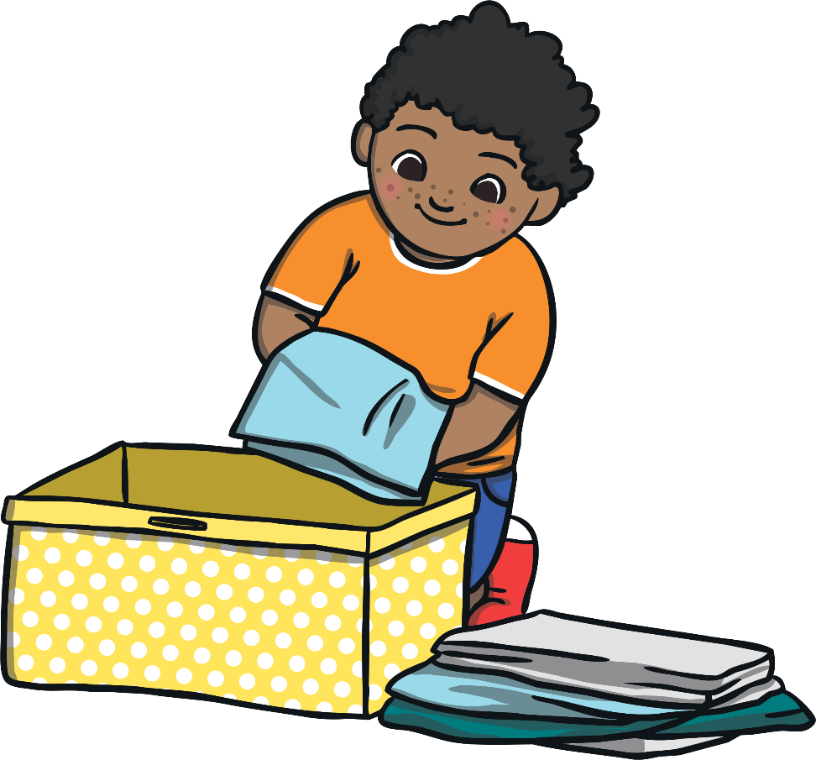

At the moment, the school I go to is closed. The school is closed to keep me safe. This means that I will be doing my schoolwork   
at home.

My name is .

My teacher is .

I am years old.

I go to school.

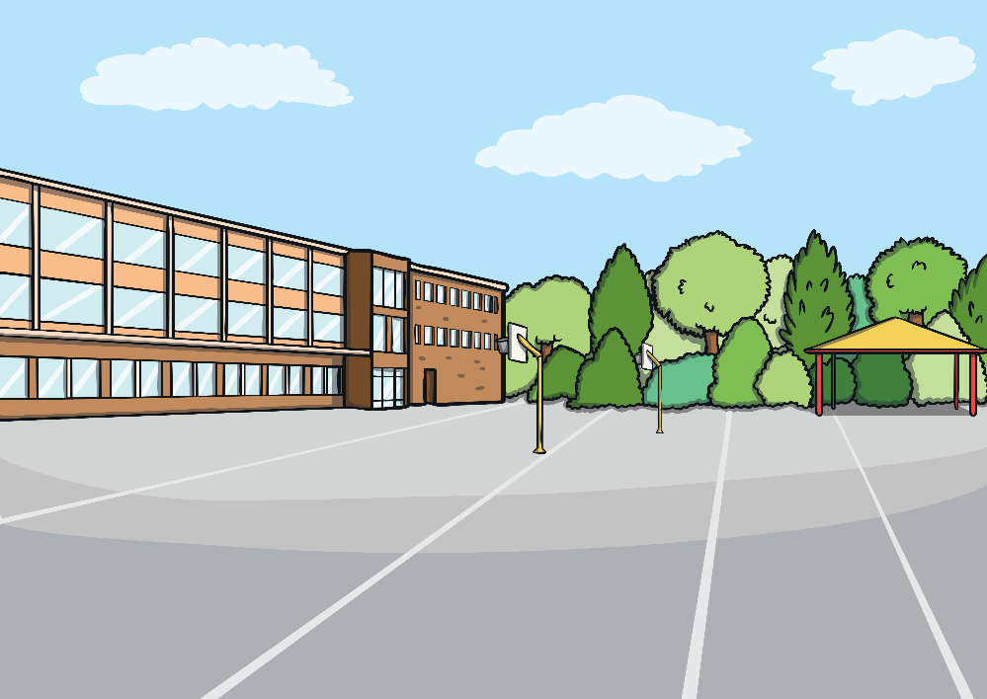



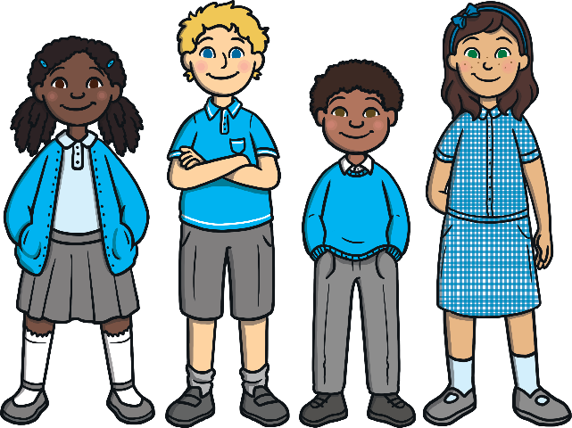

Helping my parents/carers to do jobs around the house is a good thing. It means they will have less to do and be able to spend more time with me. It will also keep me busy. This is a good thing.

When I have finished my schoolwork, I will be able to help my parents/carers to do jobs around the house.

Jobs that I could do include:

* Tidying my bedroom
* Making my bed
* Washing the dishes
* Baking cakes
* Playing with the dog in the garden

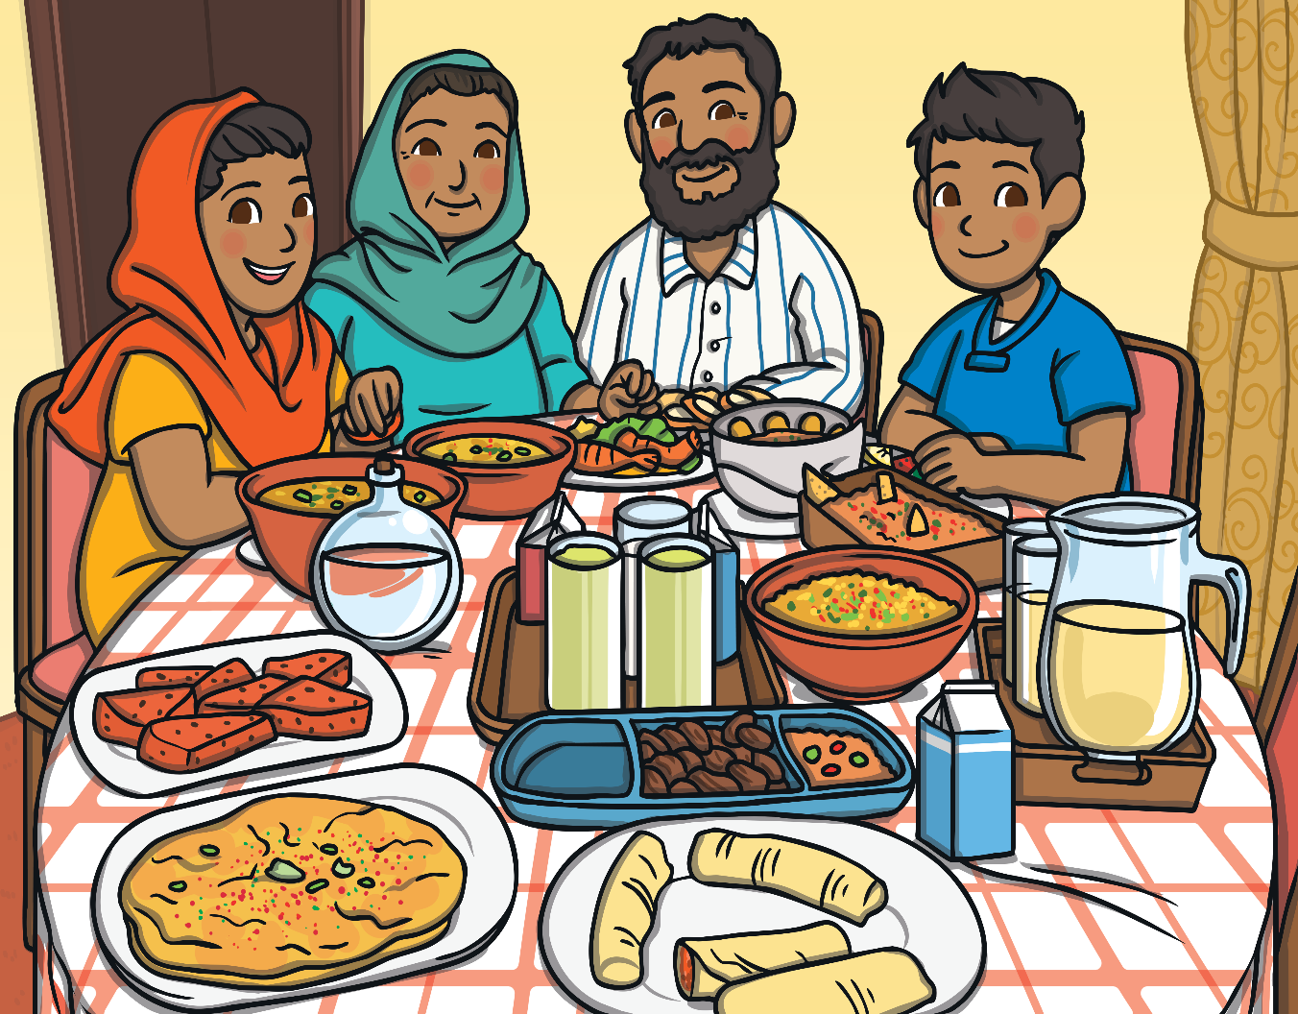

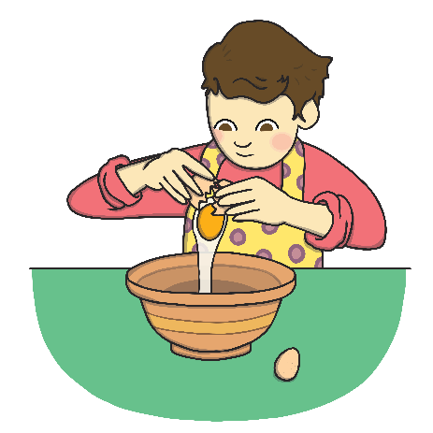

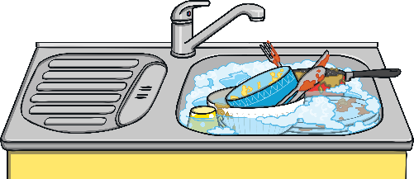

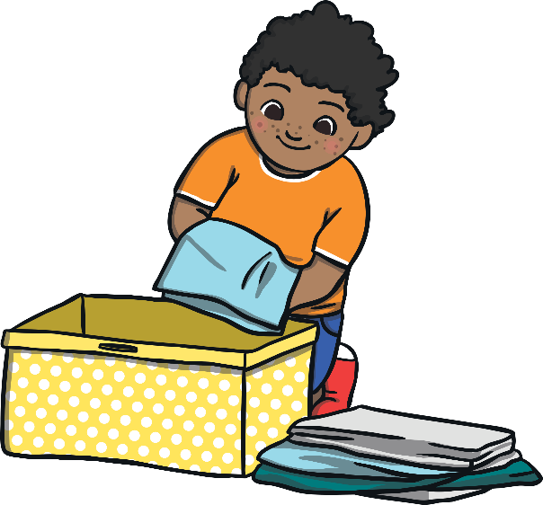

This will make them very proud.

I will try hard to help my parents/carers to do jobs around the house.

